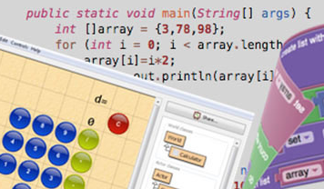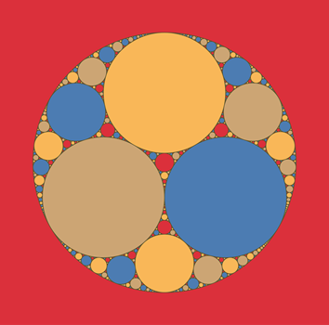MOCA’s 1st ANNUAL

for more information contact: Michael Young at myoung@iastate.edu

SOLVE-A-THON

January 13, 2015

9:00 am – 4:00 pm

**IOWA STATE UNIVERSITY**

Carver Hall, 411 Morrill Rd, Ames, IA 50011

Lorem ipsum dolor sit amet, consectetur adipisicing elit. Minima maxime quam architecto quo inventore harum ex magni, dicta impedit. Lorem ipsum dolor sit amet, consectetur adipisicing elit. Minima maxime quam architecto quo inventore harum ex magni, dicta impedit. Lorem ipsum dolor sit amet, consectetur adipisicing elit. Minima maxime quam architecto quo inventore harum ex magni, dicta impedit. Lorem ipsum dolor sit amet, consectetur adipisicing elit. Minima maxime quam architecto quo inventore harum ex magni, dicta impedit.